2021宁德五中创客作品创作方案05

项目作品案例名称：《基于Arduino的智能汽车头灯》
作品案例类别：创意智造
学校：福建省宁德市第五中学
作者：林立凡 高二（8）
指导教师：邬肖英
涉及学科或专业领域：Arduino、超声波、激光切割

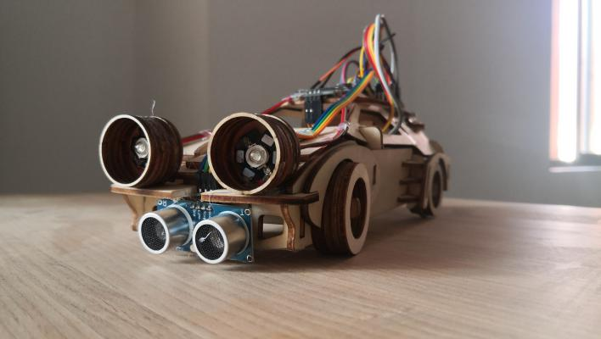
- 项目作品概述（请填写）
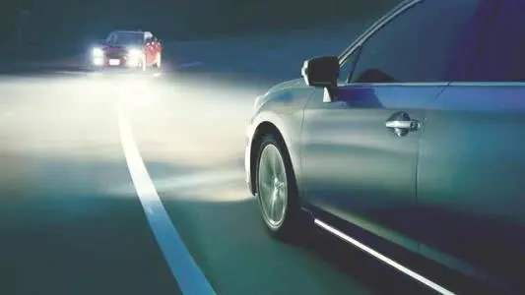
该装置要实现的功能为：
- 超声波测量洗车前方障碍物距离，在OLED屏中显示；
- LED灯模拟汽车头灯，前方有障碍物或人，车灯亮度减弱；
- 当车前方有人，距离10cm（模拟），汽车车灯减弱，并蜂鸣器报警；
- 驾驶员也可以手动控制灯的亮度。
二、主要材料
核心部件：Arduino NANO 开发板、I/O扩展板
传感器：HC-SR04超声波模块、模拟角度传感器
执行器：蜂鸣器 LED灯珠
显示器：0.91寸 白色 OLED显示屏模块128*64液晶屏 4针
三、项目作品创作过程
A、外型设计
B、硬件搭建
[材料清单]
1）Arduino NANO 开发板 X1
2）I/O扩展板 NANO 扩展板 X1
3）HC-SR04超声波模块 X1
4）模拟角度传感器 X1
5）蜂鸣器 X1
6）LED灯珠 X3
7）OLED显示屏 X1

[硬件连接]
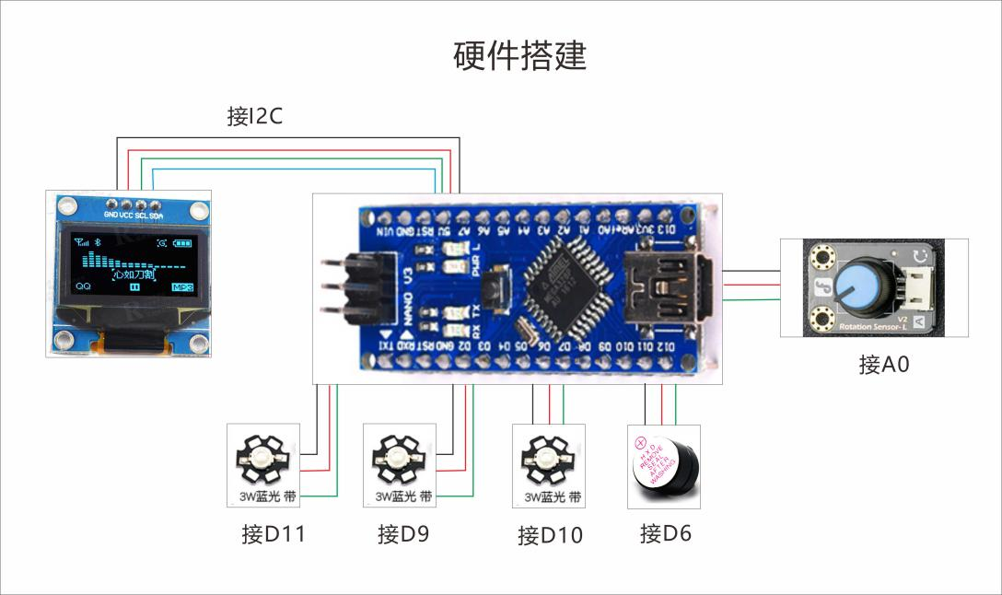
- 编程程序
主程序
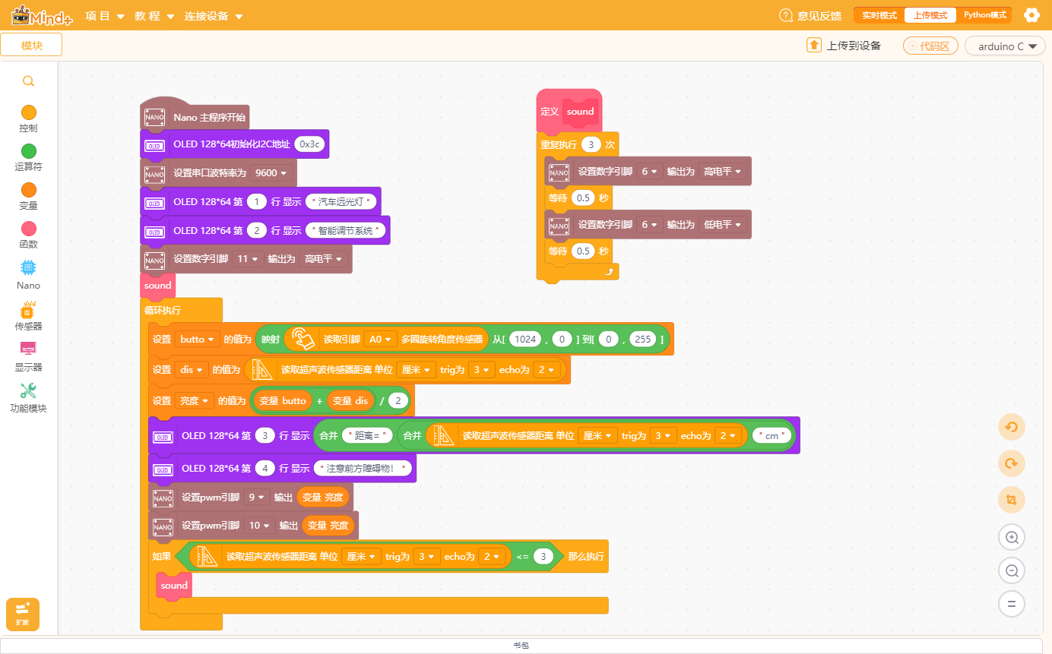

编程代码：
/*!
* MindPlus
* nano
*
*/
#include <DFRobot_URM10.h>
#include <DFRobot_SSD1306_I2C.h>

// 动态变量
volatile float mind_n_butto, mind_n_dis, mind_n_LiangDu;
// 函数声明
void DF_sound();
// 静态常量
const chCode chBuf[] = {
{0x6c7d,0xe6b1bd,0xC6FB,{0x01,0x00,0x21,0x00,0x11,0xfc,0x12,0x00,0x84,0x00,0x41,0xf8,0x48,0x00,0x08,0x00,0x13,0xf8,0x10,0x08,0xe0,0x08,0x20,0x08,0x20,0x0a,0x20,0x0a,0x20,0x06,0x00,0x02}},
{0x8f66,0xe8bda6,0xB3B5,{0x02,0x00,0x02,0x00,0x02,0x00,0x7f,0xfc,0x04,0x00,0x09,0x00,0x11,0x00,0x21,0x00,0x3f,0xf8,0x01,0x00,0x01,0x00,0xff,0xfe,0x01,0x00,0x01,0x00,0x01,0x00,0x01,0x00}},
{0x8fdc,0xe8bf9c,0xD4B6,{0x00,0x00,0x23,0xf8,0x10,0x00,0x10,0x00,0x00,0x00,0x07,0xfc,0xf1,0x20,0x11,0x20,0x11,0x20,0x11,0x20,0x11,0x24,0x12,0x24,0x12,0x24,0x14,0x1c,0x28,0x00,0x47,0xfe}},
{0x5149,0xe58589,0xB9E2,{0x01,0x00,0x21,0x08,0x11,0x08,0x09,0x10,0x09,0x20,0x01,0x00,0xff,0xfe,0x04,0x40,0x04,0x40,0x04,0x40,0x04,0x40,0x08,0x42,0x08,0x42,0x10,0x42,0x20,0x3e,0xc0,0x00}},
{0x706f,0xe781af,0xB5C6,{0x10,0x00,0x10,0x00,0x13,0xfe,0x10,0x20,0x54,0x20,0x58,0x20,0x50,0x20,0x90,0x20,0x10,0x20,0x10,0x20,0x10,0x20,0x28,0x20,0x24,0x20,0x44,0x20,0x40,0xa0,0x80,0x40}},
{0x667a,0xe699ba,0xD6C7,{0x20,0x00,0x3e,0x7c,0x48,0x44,0x08,0x44,0xff,0x44,0x14,0x44,0x22,0x7c,0x40,0x00,0x1f,0xf0,0x10,0x10,0x10,0x10,0x1f,0xf0,0x10,0x10,0x10,0x10,0x1f,0xf0,0x10,0x10}},
{0x80fd,0xe883bd,0xC4DC,{0x10,0x40,0x24,0x44,0x42,0x48,0xff,0x70,0x01,0x40,0x00,0x42,0x7e,0x42,0x42,0x3e,0x42,0x00,0x7e,0x44,0x42,0x48,0x42,0x70,0x7e,0x40,0x42,0x42,0x4a,0x42,0x44,0x3e}},
{0x8c03,0xe8b083,0xB5F7,{0x00,0x00,0x47,0xfc,0x24,0x44,0x24,0x44,0x05,0xf4,0x04,0x44,0xe4,0x44,0x27,0xfc,0x24,0x04,0x25,0xf4,0x25,0x14,0x2d,0x14,0x35,0xf4,0x24,0x04,0x04,0x14,0x08,0x08}},
{0x8282,0xe88a82,0xBDDA,{0x08,0x20,0x08,0x20,0xff,0xfe,0x08,0x20,0x08,0x20,0x00,0x00,0x7f,0xf8,0x02,0x08,0x02,0x08,0x02,0x08,0x02,0x08,0x02,0x50,0x02,0x20,0x02,0x00,0x02,0x00,0x02,0x00}},
{0x7cfb,0xe7b3bb,0xCFB5,{0x00,0xf8,0x3f,0x00,0x04,0x00,0x08,0x20,0x10,0x40,0x3f,0x80,0x01,0x00,0x06,0x10,0x18,0x08,0x7f,0xfc,0x01,0x04,0x09,0x20,0x11,0x10,0x21,0x08,0x45,0x04,0x02,0x00}},
{0x7edf,0xe7bb9f,0xCDB3,{0x10,0x40,0x10,0x20,0x20,0x20,0x23,0xfe,0x48,0x40,0xf8,0x88,0x11,0x04,0x23,0xfe,0x40,0x92,0xf8,0x90,0x40,0x90,0x00,0x90,0x19,0x12,0xe1,0x12,0x42,0x0e,0x04,0x00}},
{0x8ddd,0xe8b79d,0xBEE0,{0x00,0x00,0x7d,0xfe,0x45,0x00,0x45,0x00,0x45,0x00,0x7d,0xfc,0x11,0x04,0x11,0x04,0x5d,0x04,0x51,0x04,0x51,0xfc,0x51,0x00,0x5d,0x00,0xe1,0x00,0x01,0xfe,0x00,0x00}},
{0x79bb,0xe7a6bb,0xC0EB,{0x02,0x00,0x01,0x00,0xff,0xfe,0x00,0x00,0x14,0x50,0x13,0x90,0x14,0x50,0x1f,0xf0,0x01,0x00,0x7f,0xfc,0x42,0x04,0x44,0x44,0x4f,0xe4,0x44,0x24,0x40,0x14,0x40,0x08}},
{0x6ce8,0xe6b3a8,0xD7A2,{0x00,0x80,0x20,0x40,0x10,0x00,0x17,0xfc,0x80,0x40,0x40,0x40,0x40,0x40,0x10,0x40,0x13,0xfc,0x20,0x40,0xe0,0x40,0x20,0x40,0x20,0x40,0x20,0x40,0x2f,0xfe,0x00,0x00}},
{0x610f,0xe6848f,0xD2E2,{0x01,0x00,0x3f,0xf8,0x08,0x20,0x04,0x40,0xff,0xfe,0x00,0x00,0x1f,0xf0,0x10,0x10,0x1f,0xf0,0x10,0x10,0x1f,0xf0,0x02,0x00,0x51,0x04,0x51,0x12,0x90,0x12,0x0f,0xf0}},
{0x524d,0xe5898d,0xC7B0,{0x10,0x10,0x08,0x10,0x08,0x20,0xff,0xfe,0x00,0x00,0x3e,0x08,0x22,0x48,0x22,0x48,0x3e,0x48,0x22,0x48,0x22,0x48,0x3e,0x48,0x22,0x08,0x22,0x08,0x2a,0x28,0x24,0x10}},
{0x65b9,0xe696b9,0xB7BD,{0x02,0x00,0x01,0x00,0x01,0x00,0xff,0xfe,0x04,0x00,0x04,0x00,0x04,0x00,0x07,0xf0,0x04,0x10,0x04,0x10,0x04,0x10,0x08,0x10,0x08,0x10,0x10,0x10,0x20,0xa0,0x40,0x40}},
{0x969c,0xe99a9c,0xD5CF,{0x00,0x20,0x7d,0xfc,0x44,0x88,0x48,0x50,0x4b,0xfe,0x50,0x00,0x49,0xfc,0x49,0x04,0x45,0xfc,0x45,0x04,0x45,0xfc,0x68,0x20,0x53,0xfe,0x40,0x20,0x40,0x20,0x40,0x20}},
{0x788d,0xe7a28d,0xB0AD,{0x00,0x00,0x01,0xf8,0xfd,0x08,0x11,0xf8,0x11,0x08,0x21,0xf8,0x3c,0x00,0x65,0xfc,0x64,0x10,0xa7,0xfe,0x24,0x10,0x25,0x10,0x3c,0x90,0x24,0x10,0x20,0x50,0x00,0x20}},
{0x7269,0xe789a9,0xCEEF,{0x10,0x80,0x10,0x80,0x50,0x80,0x50,0xfc,0x7d,0x54,0x52,0x54,0x90,0x54,0x10,0x94,0x1c,0x94,0xf1,0x24,0x52,0x24,0x10,0x44,0x10,0x44,0x10,0x84,0x11,0x28,0x10,0x10}},
{0xff01,0xefbc81,0xA3A1,{0x00,0x00,0x10,0x00,0x10,0x00,0x10,0x00,0x10,0x00,0x10,0x00,0x10,0x00,0x10,0x00,0x10,0x00,0x10,0x00,0x00,0x00,0x00,0x00,0x10,0x00,0x10,0x00,0x00,0x00,0x00,0x00}}
};
// 创建对象
DFRobot_SSD1306_I2C oled12864;
DFRobot_URM10 urm10;

// 主程序开始
void setup() {
oled12864.setChCode(chBuf);
oled12864.begin(0x3c);
Serial.begin(9600);
oled12864.setCursorLine(1);
oled12864.printLine("汽车远光灯");
oled12864.setCursorLine(2);
oled12864.printLine("智能调节系统");
digitalWrite(11, HIGH);
DF_sound();
}
void loop() {
mind_n_butto = (map(analogRead(A0), 1024, 0, 0, 255));
mind_n_dis = (urm10.getDistanceCM(3, 2));
mind_n_LiangDu = ((mind_n_butto + mind_n_dis) / 2);
oled12864.setCursorLine(3);
oled12864.printLine((String("距离=") + String((String((urm10.getDistanceCM(3, 2))) + String("cm")))));
oled12864.setCursorLine(4);
oled12864.printLine("注意前方障碍物！");
analogWrite(9, mind_n_LiangDu);
analogWrite(10, mind_n_LiangDu);
if (((urm10.getDistanceCM(3, 2))<=3)) {
DF_sound();
}
}

// 自定义函数
void DF_sound() {
for (int index = 0; index < 3; index++) {
digitalWrite(6, HIGH);
delay(500);
digitalWrite(6, LOW);
delay(500);
}
}

- 作品完成
（设计、制作现场照片）

四、作品设计的体会
设计源于生活，又服务于生活，人们的生活离不开设计，设计也离不开生活给予的灵感，所以说设计与我们的生活息息相关。这次设计我们收获很多、学会很多、比以往更有耐心很多。希望我们的产品能真正应用到人们的实际生活中，给人们的生活带来方便，保障人们的安全。

